|  |  |
| --- | --- |
| D:\Downloads\aQmYMVZ2p8MxFkv9DjpTh6RQAbBr35wZsX4GvRQDqMU.png  (World Of Warcraft Reddit, 2018)  PROJECT PROPOSAL  *World of Warcraft Add-On* | *Hot Topic* |

**Contents**

**List of Figures** 4

**List of Tables** 4

**1.** **Introduction** 6

**1.1** **Background** 6

**1.2** **Current Situation** 6

**1.3** **Current Situation and Measurable Organizational Value (MOV)** 6

**1.4** **Current Situation and Scope** 7

**1.5** **Possible Solution** 7

**1.6** **Project aim and Report Structure** 8

**2.** **Literature Review** 9

**2.1** **Existing System** 9

**2.1.1.** **How WoW is structured** 9

**2.1.2.** **WoW group finder** 10

**2.1.3.** **WoW Content** 10

**2.1.4.** **WoW’s lore (basic)** 11

**2.1.5.** **WoW’s gameplay** 11

**2.1.6.** **WoW Content Structure** 12

**2.2.1**  **The issue** 12

**2.2.2**  **The Impact on Players** 13

**2.2.3**  **Existing Systems** 14

**2.2.4**  **Added Value** 15

**3.** **Research Approach** 16

**3.1**  **Research Methodologies** 16

**3.1.1**  **Quantitative Research** 16

**3.1.2**  **Qualitative Research** 16

**3.1.3**  **Mixed Research** 17

**3.1.4**  **Software Development Methodology** 18

**3.2.1**  **Our Survey (Reasoning)** 18

**3.2.2**  **Data Sample** 19

**3.2.3**  **Our Survey (Results)** 19

**3.2.3.1**  **Question 1** 19

**3.2.3.2**   **Question 2** 20

**3.2.3.3**   **Question 3** 21

**3.2.3.4**   **Question 4** 22

**3.2.3.5**   **Question 5** 23

**3.2.3.6**  **Question 6** 24

**3.2.3.7**   **Question 7** 25

**3.2.3.8**   **Question 8** 26

**3.2.3.9**   **Question 9** 27

**3.2.3.10** **Question 10** 28

**3.2.3**  **Our Survey Summary (What we learned and data collection process)** 29

**3.2.4 Our Survey (Relations to functionality)** 30

**4.** **Planning and Resources Required** 32

**4.1** **Team Roles Table** 32

**4.2** **Project Team Table** 32

**4.3.1.** **Google Forms** 33

**4.2.1.1.** **Logo** 33

**4.2.1.2.** **Survey Creation** 34

**4.2.1.3.** **Responses and Graphs** 34

**4.3.2.** **Notepad++** 35

**4.3.2.1** **Logo** 35

**4.3.2.2** **Coding in Notepad++** 36

**4.3.2.3** **Coding with tabs** 36

**4.4.1.** **Forming and Planning Phase** 37

**4.4.2.** **Research Topic Phase** 37

**4.4.3.** **Data Collection Phase** 37

**4.4.4.** **Writing Proposal Phase** 38

**4.4.5.** **Proposal Presentation Phase** 38

**4.4.6.** **Design Phase** 38

**4.4.7.** **Development Phase** 39

**4.4.8.** **Documentation Phase** 39

**4.5 Project Work Structure** 40

**4.6 Key risks and impact** 47

**4.6.1. Risks associated with project** 47

**4.6.2**  **Resolution of Risks Table** 48

**5.** **Conclusion** 49

**References** 50

**APPENDIX 1** 51

**APPENDIX 2** 52

**APPENDIX 3** 53

Faculty of Business and Information Technology 54

502.714 – Hot Topic in Software ***Proposal Cover Sheet*** 54

**Declaration of Original Authorship** 54

# **List of Figures**

Figure 1: Group Finder System 12

Figure 2: Bad Apples User Interface 14

Figure 3: Bad Apples Invite Waring Prompt 14

Figure 4: Bad Apples Non-Flagged Player 15

Figure 5: Bad Apples Flagged Player 15

Figure 6: Quantitative Gender Question 16

Figure 7: Qualitative Favourite Coffee Shop Question 16

Figure 8: Quantitative Rage Question 17

Figure 9: Data Sample Records 19

Figure 10: Graph 1 Gender Pie-Chart 19

Figure 11: Graph 2 Age Category Pie-Chart 20

Figure 12: Graph 3 Play Time Pie-Chart 21

Figure 13: Graph 4 Frustration Pie Chart 22

Figure 14: Frustration Responses 23

Figure 15: Graph 5 Player Experience Pie-Chart 24

Figure 16: Player Experience Responses 25

Figure 17: Graph 6 Player Experience Frequency Pie-Chart 26

Figure 18: Flow-on Experience of a Ruined Experience Responses 27

Figure 19: Graph 8 Group Finder Satisfaction – Pie Chart 28

Figure 20: Graph 9 Potential Features - Bar Graph 30

Figure 21: Player Responses Potential Features 31

Figure 22: Google Forms Logo 33

Figure 23: Google Forms Survey Creation 34

Figure 24: Google Forms Responses and Graphs 34

Figure 25: Notepad++ Logo 35

Figure 26: Coding in Notepad++ 36

Figure 27: Coding with Tabs in Notepad++ 36

Figure 28: APPENDIX 1 51

Figure 29: APPENDIX 2 52

Figure 30:APPENDIX 3 53

# **List of Tables**

Table 1: Team Roles Table 29

Table 2:Project Team Table 29

Table 3:Forming and Planning Phase Table 37

Table 4: Research Topic Phase Table 38

Table 5: Data Collection Phase Table 39

Table 6:Writing Proposal Phase Table 40

Table 7: Proposal Presentation Phase Table 41

Table 8:Proposal Presentation Phase Table 42

Table 9:Development Phase Table 43

Table 10:Documentation Phase Table 43

Table 11: Resolution of Risks Table 45

# **Introduction**

## **Background**

World of Warcraft (WoW) (Blizzard, 2018), developed by Blizzard Entertainment, is currently the most popular massively multiplayer online role-playing game(MMORPG) in the world. Although Blizzard discontinued releasing annual/monthly player count reports during a trough in popularity in 2015 (Raizing, 2017), a well-known YouTube content creator called “MMOByte” has data mined evidence to prove that the game is still dominating the MMORPG market (MMOByte, 2017). WoW peaked at an impressive 12 million active subscribers in 2012 before gradually receding to below 7.5 million before they stopped releasing the active subscriber numbers in 2015, however they have still been miles ahead of all competitors within the MMORPG genre (Raizing, 2017).

## **Current Situation**

Generally, all online gaming communities have toxicity (negative behaviour). WoW is no exception to this rule, in fact, WoW was publicly voted as the 9th most toxic online gaming community out there (Brinks, n.d.). Toxicity in an online gaming community such as Wow’s tends to spread e.g. if a player insults another player just because they are having a bad day, it will bring down the confidence/happiness of that person no matter what type of person they are, making that player more likely to insult others. This is a chain reaction where one player can end up effecting hundreds or even thousands of players experience thus, lowering the average enjoyment the overall player-base is getting out of playing the game.

## **Current Situation and Measurable Organizational Value (MOV)**

The toxicity in the WoW community is mostly broken up into three major categories. The first of which deals mainly with communication among the current player base. This is evident by the games general group chat, that can be accessed by all players. A lot of the time players are seen insulting each other for a multitude of reasons ranging from skill level to getting personal. Secondly, the communities diverse level of players (both experience levels and skill levels) can, and often does, cause a clash. This clash is because good players don’t want to have bad players or unfortunately even new players in their groups because they don’t want their personal progress to be held back. Lastly, the reliability of players can cause extremely levels of frustration, as WoW is considered a team game and progress can only go so far alone. If one player out of a group of 5 leaves the game unannounced half way through an activity, the other 4 players have little to no chance of completing said activity. These are the 3 main reasons for the communities’ toxicity and having an in-depth understanding of these 3 aspects is paramount towards our MOV which is to remove/reduce toxicity and general time-wasters, which will in turn, positively impact the communities experience and therefore enjoyment of the game and potentially build the community to be larger and more accessible for an entire plethora of players. Although outside of our scope, a stronger community will prevent the games lifecycle from dying prematurely, as we can clearly see from the monthly player count graphs, the game has been on a downwards recession since 2012 (Raizing, 2017).

## **Current Situation and Scope**

Due to WoW being an MMORPG, most of the games content is designed to be done in an online team. Teams are formed through a group finder system that allows players to queue up for a specific group activity and the group leader can choose whether to invite them. The biggest problem in WoW is that there is no way of telling how good or bad, polite or rude, reliable or unreliable a player is within the group making system. The only information you currently get on a player is how strong they are going to be is based on the in-game level displayed next to their profile. This however is a poor indication of how much a player will contribute to a group activity, as in game levels only indicates how long players have played WoW and not actual completion rates for activities. With this said our group looked at the game in its existing state and we saw an opportunity to not only minimise the toxicity but also improve the quality of players found in the group finder system which is precisely what our MOV states we hope to achieve.

## **Possible Solution**

One of our group members is considered a veteran player of WoW and has long sought after a community driven system that shows more information on how a player is likely to act/play while in his group, based on more than just the statistical impact a player’s character is capable of. This is where our idea for the project came from as we think that a more in-depth character display would fix a lot of these problems. With this said, our idea stems from an interface modification system(modding) that Blizzard allows called ‘add-ons’. We plan to add functionalities that will help to minimize and manage the 3 aspects of toxicity that we explained above in the form of said ‘add-ons’. This will be achieved by a datamining process that is both simple to understand, yet an effective way to judge a player’s personal traits through the eyes of the community. When creating a group in WoW, you could be looking at committing 4 hours or more with that same group of players, so we believe that it is quintessential for a player to able to see more information on the type of people they are inviting to their groups for activities.

## **Project aim and Report Structure**

Our overall aim of the project is to improve on the current matchmaking system to both promote good behaviour from players and punish bad behaviour. Our objectives are to allow a player to personally blacklist and whitelist certain players that they don’t want to play with anymore, and to be able to see the feedback from other players to gauge how good/bad a player is at the game specifically, how polite/toxic a player is and how reliable they are. To summarize, we would like to implement a rating system that will display a player’s reputation to everyone that downloads this add-on. Our report will detail the following:

* + A literature review that highlights the state that WoW is in today in detail, the current issues, how they impact the players, a system with a similar intent to ours that failed and lastly the value that we are adding to the game.
  + We will also display information on our research approach/methodology which will include a descriptive analysis fundamentally based on our player survey. We will break down the results from both the surveying process and the survey responses and lastly tie in the results of the survey with how it pinpoints to adding the functionality
  + We will also prepare an accurate Gantt chart of our tasks, activities and exactly what we hope to achieve in each of the phases, alongside a resource management plan and an insight to our thought process behind the risk management plan of the project.
  + Lastly, we will prepare the conclusion that will give a brief overview of the project proposal as well as a paragraph highlighting our personal thoughts on the entire project.

# **Literature Review**

## **Existing System**

### **How WoW is structured**

The game in question is none other than the king of the MMORPG genre, World of Warcraft (WoW). MMORPG standing for massively multiplayer online role-playing game has key words that tell a lot about the genre of game. Most online games are considered MO’s which just stands for multiplayer online. The extra M for massively is unique to a very small group of games including WoW, as it is one big open world that millions of players can play in and interact with each other at the same time. This would require an unimaginable amount of processing power as, upwards of 10 million people can be in one place at the same time, so the game is split up into realms, zones and instances. Players automatically phase in and out of each of these to avoid too much information overloading the servers at any time. A realm is essentially the games servers. There are hundreds of these to choose from and they each have certain tags including PvP (Player vs player) meaning that opposing factions can fight to the death if they see fit anywhere in the world bar a few small safe zones e.g. Cities and large villages, PvE (Player vs environment) which is a more co-operative play style where players can either play solo content, or connect with other players in groups that range anywhere from 5 to 40 players at once and RP (Role-play) is less about the game mechanics, and more centred around players taking the roles of their in-game characters and essentially acting as a character in a story that they have written, rendering WoW as only a medium for them to express themselves in these stories and to other players. Zones and instances are more closely related than realms, as zones are certain places divided by borders in WoW’s huge open world e.g. like how a continent is divided by different countries, and countries are divided by different states etc. Instances however, are accessible through portals found within the game and take the player to another (smaller) zone entirely separate from the open world of the game.

### **WoW group finder**

The way WoW is separated in such a multitude of ways would lead one to believe that could be rare to find other players unless in well-known areas such as one of the main cities. Surprisingly enough, this is quite the opposite. The entire fundamental backbone of the game is a group finder system which can connect players who are on opposite ends of the map, in and out of instances and even on different realms through cross-realm matchmaking. The group finder system is a medium of connecting players together to tackle activities that are impossible to overcome individually, which also happens to be 80% of the games relevant content.

### **WoW Content**

WoW was released officially in 2004 by Blizzard Entertainment. It was designed as a revamped sequel to the popular RPG series Warcraft and is based roughly 4 years after the final Warcraft game ‘Warcraft III’. WoW grew into popularity very fast as it was one of the first MMORPG’s of its kind, not to mention how most Warcraft fans wouldn’t have hesitated to jump on the hype train. The first 2 years of WoW was a huge success, however players were running out of content to do, so Blizzard developed an expansion pack known as TBC (The Burning Crusade) which added another 2 years of content for its player-base to dig into. This bi-yearly expansion pack system has worked for Blizzard almost flawlessly throughout the years and they are still sticking by it to this day. There have been 6 expansions since the initial ‘vanilla’ release of the game and they go as follows:

* The Burning Crusade
* Wrath of the Lich King
* Cataclysm, Mists of Pandaria
* Warlords of Draenor
* Legion (current)
* Battle for Azeroth (future)

### **WoW’s lore (basic)**

WoW is predominantly set on the same planet in the same universe as the Warcraft franchise, Azeroth. This world is a fantasy-based RPG with kings, queens, dragons, gods, titans, magic, swords you name it. Azeroth’s inhabitants are fundamentally split into two factions, Alliance and Horde. Initially Alliance are viewed as the generic ‘good-guys’ in the game and horde being the villains, but as we dive deeper into the games rich lore, we find that both sides are good and bad in their own ways. Although Alliance and Horde have their differences and love nothing more than to kill each other on sight, we often see them working in tandem to defeat the greater enemy.

### **WoW’s gameplay**

There are players in WoW that have thousands upon thousands of hours logged into the game and still haven’t completed everything there is to do in this gigantic online world. WoW’s 12 different classes can each be slotted into one of 3 different roles which are known as Tank (The player who will be drawing the monster’s attention and is designed to be able to receive devastating attacks and survive), Healer (which are the people whose job it is to keep the whole group alive throughout various activities) and the DPS (DPS stands for damage per second and the idea behind this role is that they are essentially glass cannons. They dish out immense amounts of damage to enemies but if that enemies focus was drawn to them, they would die within a few seconds). The content in WoW is quite often split up into three major sections; Solo, PvP and PvE. Solo content is mostly quests, exploration, battling with your pets, doing professions e.g. cooking, fishing, mining etc. and achievement hunting for all the completionists (Any player who enjoys completing all aspects of a game ranging from quests to collecting pets to miscellaneous achievements) out there.

### **WoW Content Structure**

PvP content can include 1 vs 1 player duels, fights to the death in the world (often between alliance and horde players), raiding the enemy cities to kill their kings/chiefs and lastly, battlegrounds/arenas which are instance based objective styled game modes such as generic capture the flag, death match etc. Finally, we come to PvE which, as of right now, is considered the largest aspect of WoW. PvE can be divided into two main categories. Dungeons and Raids. Dungeons are a group of 5 people (typically 1 tank, 1 healer and 3 DPS) that have a time limit to complete an instance involving multiple boss fights and many different enemies. The quicker the 5 players complete the dungeon; the more rewards they get at the end. Raids are a completely different scene. Where dungeons are about how quickly a group can defeat all enemies within an instance in an allotted time, raids are about whether a group can even kill the boss, and the main difference, is that a raid group can require upwards of 20 players to work together in harmony and good coordination. This is where problems can begin to stem from, as if one person is not on board with the rest of the group, 1 out of 19 players can cause all 20 of them to die.

### **2.2.1 The issue**

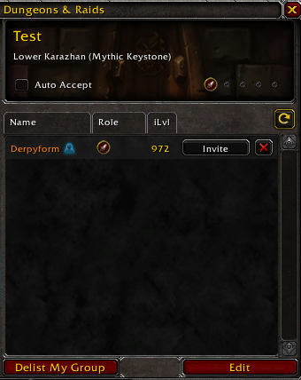As explained in previous sections, it is very clear to see that online player cooperation in WoW is extremely important. Most of the relevant content within the game is near to impossible to complete alone, therefore it is necessary for there to be a competent group finder system. It is very clear the WoW’s current group finder system has major issues and no way to overcome them.

* What the group leader has named the group
* What activity the group is for
* Decline button
* Invite button
* Item level meaning how powerful the player is
* Role of the applicants (DPS, Tank or Healer)
* Name of the applicants

Figure 1: Group Finder System

The group finder system within the game is extremely simple and lacks key features seen in similar games. These key features include systems to gauge how good a player is (not based on in game stats), A player’s reputation to see if that player is likely to be toxic and bring down the groups morale and to see how reliable a player is e.g. if they are likely to leave the group half way through an activity if things start to become challenging. Due to the WoW community being far from perfect, there are a lot of toxic players that spread toxicity like a virus resulting in a less enjoyable WoW experience for all players.

### **2.2.2 The Impact on Players**

When trying to overcome challenges in WoW, while the rewards can be bountiful, failure can be extremely punishing. In terms of the aforementioned dungeons and raids (PvE), players are given a keystone (opportunity) every week which allows them to enter a timed dungeon that yields valuable loot. The shear fact that this dungeon is timed shows that a competent group would be required to finish it on time. If a keystone is not completed within the time limit it is considered ‘depleted’ and no rewards can be gained from finishing the dungeon. It is imperative that for your weekly keystone you have a group of decent players as it is a one-time opportunity to gain some of the best loot obtainable each week. One false move within these keystone dungeons can result in death no matter how powerful the player is. This is what separates the good players from the bad players. A bad player can still be very powerful but not impactful at all within the dungeon. Certain players who have negative attitudes are known to regularly start to insult their team mates if things aren’t going as smoothly as they would have hoped. This brings down the team’s morale which leads to people not performing to the best of their ability, plus if that player is constantly typing in the middle of a timed dungeon run, they have significantly less uptime on progressing through it. Lastly if something goes wrong and a player leaves in the middle of the dungeon, there is no system in place to replace said player, so the dungeon run is rendered near to if not impossible. All these aspects of the game make WoW a less enjoyable experience and can make players want to quit.

### **2.2.3 Existing Systems**

There is already a small addon with similar ideas to ours in the game called BadApples. BadApples is an outdated system with the sole purpose to blacklist players personally. When you come across a player that you would not like to play with again, BadApples allows you to add them to a list.

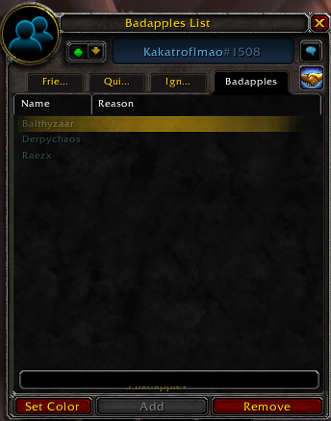

(Blizzard, 2018)

Figure 2: Bad Apples User Interface

This is the BadApples blacklist GUI which shows a list of the players the user has personally blacklisted. The user is given a prompt each time they try to invite any player on this list.

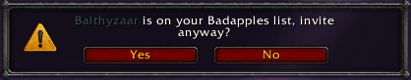

(Blizzard, 2018)

Figure 3: Bad Apples Invite Waring Prompt

Finally, if the user has a blacklisted player targeted, the appear slightly different as follows:

Balthyzaar is blacklisted as seen by the black background behind his players name, whereas Faeliana has a blue background behind her name, as with every other player in the game that hasn’t been blacklisted.

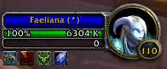

(Blizzard, 2018)

Figure 4: Bad Apples Non-Flagged Player

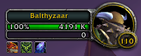

(Blizzard, 2018)

Figure 5: Bad Apples Flagged Player

### **2.2.4 Added Value**

The value that our addon is going to add to the game is a far more in-depth group finder system to give players more of an insight as to who they are inviting to their group activities, and additionally promoting good behaviour from players to make them appear more desirable when queuing for a group.

# **Research Approach**

### **3.1 Research Methodologies**

Research methodologies are variety of systematic plans for conducting research. There are 3 different types of these methodologies which are as follows: Quantitative, Qualitative and mixed.

**3.1.1 Quantitative Research**  
Quantitative research is research that can be put into numbers. For example, a survey with yes/no questions and multiple choice etc that can be condensed down into numerical data and used to define trends and get a general consensus on the public’s opinions on the research topic. When acquiring information, data gained in a quantitative manner is typically gained from asking people the Who and What questions (McKee, 2013).

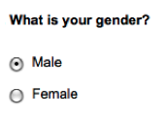

Figure 6: Quantitative Gender Question

*(McKee, 2013)*

**3.1.2 Qualitative Research**Qualitative research is research where public are asked to write their personal opinions in detail. This data cannot be put on a graph or into numbers as every entry will be different. This type of research can be seen in surveys that ask you to leave a comment, short answer and long answer questions. Whereas quantitative is more about the numbers and the who and what questions, qualitative is more about why (Millikin, 2016) .

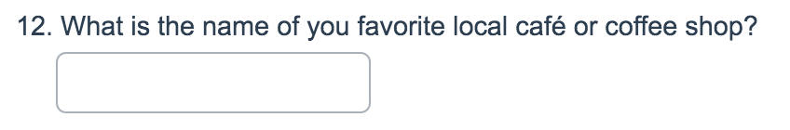

Figure 7: Qualitative Favourite Coffee Shop Question

(Millikin, 2016)

### **3.1.3 Mixed Research**

Mixed is just a combination of Qualitative and Quantitative research and is what we decided to use for our research. We thought that this would be ideal as this addon can and will cause a certain level of controversy and we believe that on top of having quantitative statistics to go with, people can also leave their own thoughts and opinions and potentially even problems that we have overlooked. The following is a snip from the survey we used as to research the WoW community’s thoughts and criticisms on our addon idea:

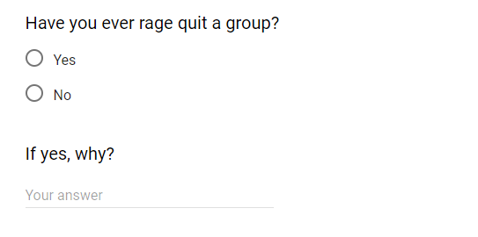

Figure 8: Quantitative Rage Question

The first question “Have you ever rage quit a group?” is quantitative so we are given a pie chart that clearly shows if yes or no is the more dominant answer. The second questions “If yes, why?” cannot be broken down into quantitative data because there are an impossibly high number of reasons that said person may have left the group, thus rendering this question qualitative, and the whole survey mixed.

### **3.1.4 Software Development Methodology**

We have decided that the best Software development methodology for the implementation phase of our addon project is to use extreme programming. We chose to use extreme programming because we do not fully know the requirements to create the addon, and as the game and community is constantly dynamically shifting, we need to be in a position where we can adapt our addon to anything. Extreme programming focuses almost solely on coding and not documentation which is another reason we decided to choose extremely programming because we do not fully understand what we are making so making a document describing what it is would be pointless. Extremely programming is mostly practicality as opposed to theory and as there’s no point in having a theoretical free optional addon, and the games UI is open source, we are just going to add in the functionalities that we believe are necessary. WoW is a really well-known game with a gigantic community and therefore it would be pointless to document on a game that already exists, the approach we are going for is a reengineering approach for a function.

### **3.2.1 Our Survey (Reasoning)**

An online survey is a data collection process which allows us to freely ask questions to a large amount of people within our target audience online. We conducted a survey to gain a better understanding of what the community thinks of the current systems, what could be improved on and to see if people are interested in our idea. For us a survey was the best way to gain information as it is free, online, accessible and lays out our data in a manageable and presentable way. Our target audience are the active members of the WoW community as they will be the stakeholders for our addon.

### **3.2.2 Data Sample**

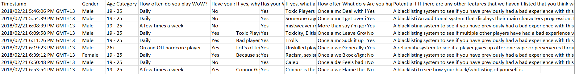

Figure 9: Data Sample Records

### **3.2.3 Our Survey (Results)**

### **3.2.3.1 Question 1**

The first segment of our survey was designed to get a general idea of the types of people we are dealing with. We started with a question on the participants gender.

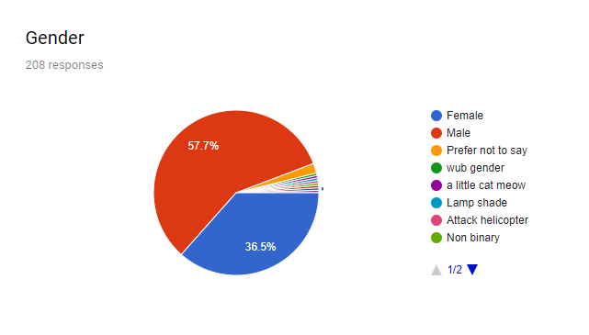

Figure 10: Graph 1 Gender Pie-Chart

As we can see most of the community are male at 57.7%, and females made up 36.5%. This left us with 5.8% of people either choosing ‘Prefer not to say’ or writing their own gender.

### **3.2.3.2 Question 2**

Next, we asked about the age category everyone fell into.

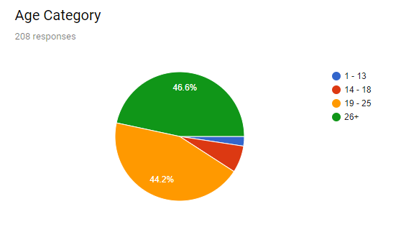

Figure 11: Graph 2 Age Category Pie-Chart

Considering 90.8% of the games community are over the age of 18, we expected that the average maturity level would be far higher than it is. We were genuinely surprised when the results came back, as we figured that a group of adults would be more than capable of playing nicely together.

After that we felt it was important to see how often our participants play WoW.

### **3.2.3.3 Question 3**

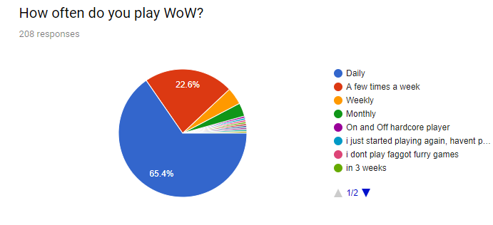

Figure 12: Graph 3 Play Time Pie-Chart

65.4% of players play the game daily which reinforces how important it is that they have a good experience when they do play. As seen here, WoW is more than just a game to most of the people who play it, it’s a part of their lives.

Now we transition into the in-game toxicity experiences that our participants have had. We asked them if they had ever been so angry/upset at a group or specific group members that they have left the group entirely.

### **3.2.3.4 Question 4**

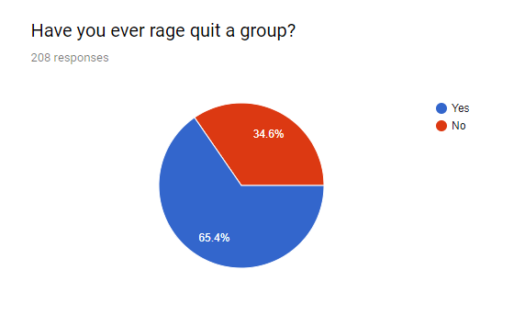

Figure 13: Graph 4 Frustration Pie Chart

As a WoW player myself (Aaaa) I was surprised that such a large percentage of players (34.6%) hadn’t left a group out of rage just because of how the community’s reputation is so bad. We also let the participants give an example of a reason they had left in the form of qualitative data.

### **3.2.3.5 Question 5**

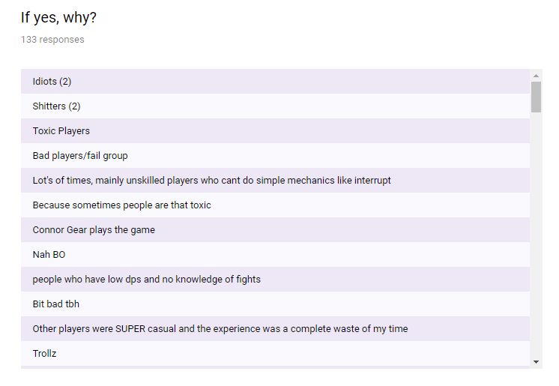.

Figure 14: Frustration Responses

As you can see, the scroll bar is very small so there were a lot of reasons that people had left groups. We then got into specifics and asked if their experience was directly ruined by another player.

### **3.2.3.6 Question 6**

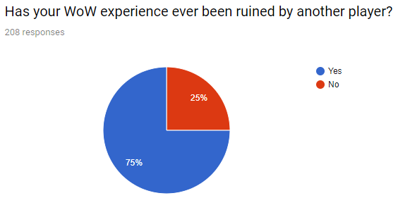

Figure 15: Graph 5 Player Experience Pie-Chart

The shear fact that 25% of people said no was a shock to us, which is sad, but the truth is that multiplayer experiences are often ruined by a few bad apples. As you can see however, 75% out of over 200 results have had their experience ruined which shows us that there is a definite problem that needs to be rectified. We left a comment section for people to again explain their ruined experiences in detail.

### **3.2.3.7 Question 7**

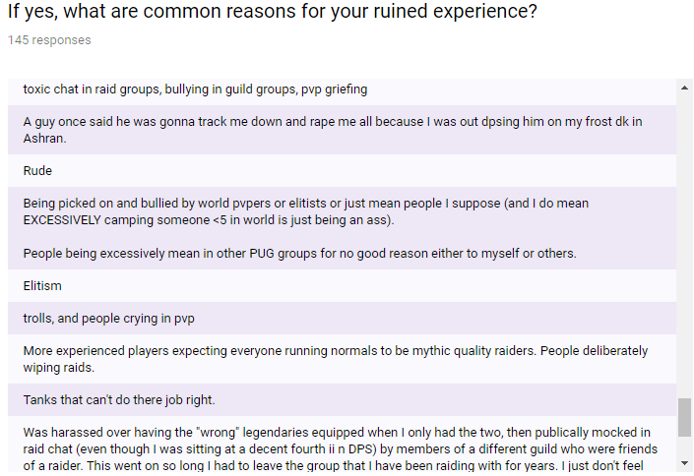

Figure 16: Player Experience Responses

Now we were looking for a rough estimate as to how often people had their WoW experiences ruined.

### **3.2.3.8 Question 8**

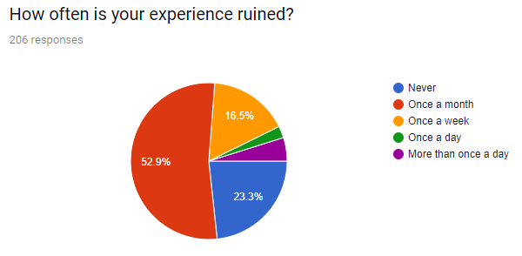

Figure 17: Graph 6 Player Experience Frequency Pie-Chart

Over half of the participants said once a month and considering when one person ruins your experience it can make you not want to play for days or even weeks, that it a very significant number. 23.3% of people said they had never had it ruined which was interesting because 25% of the same people said they had never had their experience ruined by another player so 4 peoples experiences were ruined by a part of the game not involving other people. 23.8% of people have their experiences ruined between once a week and multiple times a day which makes us feel even more obliged to fix this problem.

### **3.2.3.9 Question 9**

We let our participants explain what they do when they have had a bad experience and a small snippet of the results are as follows:

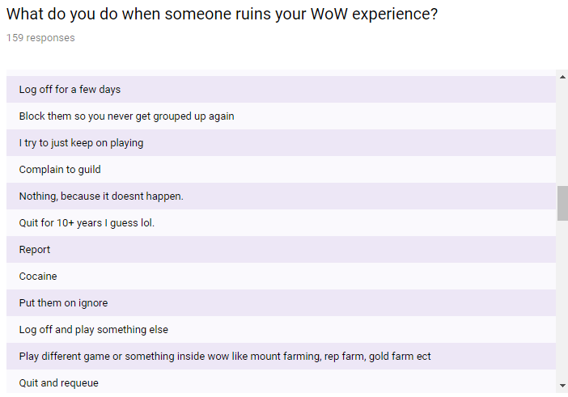

Figure 18: Flow-on Experience of a Ruined Experience Responses

### **3.2.3.10 Question 10**

Lastly, we wanted to know if people liked the current group finder system. 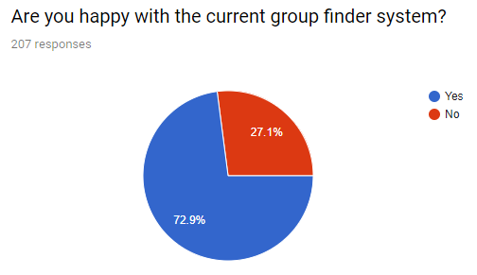

Figure 19: Graph 8 Group Finder Satisfaction – Pie Chart

This is the main data we were looking for, and despite the fact that a huge majority (72.9%) of people were happy with it, 27.1% is still a very large portion and given the player-base being in the millions, this is a ridiculous amount of people that are looking for change even with our small sample size. Another factor is that we think people are unaware of how important our addon could be considering that in every other question, the participants have expressed that they deal with toxicity sometimes daily.

### **3.2.3 Our Survey Summary (What we learned and data collection process)**

Throughout the process of getting the community to fill out the survey was far harder than we initially thought it would be. On the first night that the survey was up it took 6 hours to find 30 people. This low number was for a multitude of reasons ranging from people being scared of potential threats to their computers like malware from the surveys link, people who were too busy, people who don’t read the general chats etc. On that first night, we also learned that WoW community pages don’t allow links/surveys so the few pages we did upload it to, it was immediately removed by the admins. Lastly a good practice we learned was that it is good to know people in high places. We got the vast majority (170) of our responses from a WoW community page that didn’t remove my post because we personally know the admin and we asked her for permission first.

### **3.2.4 Our Survey (Relations to functionality)**

The final graph we came up with was from a quantitative data source and explained all the features we thought would be good, and let the participants agree or disagree, and we left a qualitative comment box at the end for any additional features people would like to see. The graph is as follows (Both of the whitelisting systems that are significantly smaller than the rest was a mistake on our part because we fixed a spelling mistake around 100 responses in and didn’t realize that it would reset. For the 4th question, the actual result was 142 (70%))

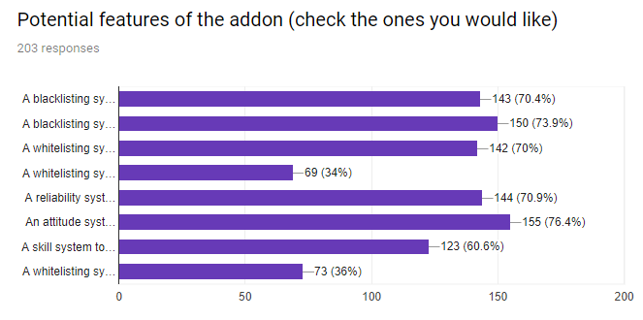

Figure 20: Graph 9 Potential Features - Bar Graph

The full options were as follows in order of the graph:

* A blacklisting system to see if you have previously had a bad experience with this player
* A blacklisting system to see if multiple other players have had a bad experience with this player
* A whitelisting system to see if you have previously had a good experience with this player
* A whitelisting system to see if multiple other players have had a good experience with this player
* A reliability system to see if a player gives up after one wipe or perseveres through the raid/dungeon
* An attitude system to see if a player is polite or toxic
* A skill system to see if a player is good at the game e.g. Do they know mechanics? Do they die every pull? Is their damage/healing respectable?

The results in this graph show us a few important things. Firstly, all of our ideas had a positive like/dislike ratio, meaning in our opinion, are worth implementing. Now it is just a matter of finding which are more important to add. The top result at 76.4% was an attitude system to see if a player is toxic or not. We will now value this feature over all other features as it is the most requested among the community. The other responses were near the same around 70% except for one that was significantly lower than the others. That one was a skill system for players to be able to tell if a requesting group member is good at the game fundamentally, and not just high geared. As we value this the lowest, it was still 60.6% requested and so we will still do our best to ensure that this functionality can be implemented within our addon. We also allowed out participants to voice their own opinions and potential adding functionalities that we missed. 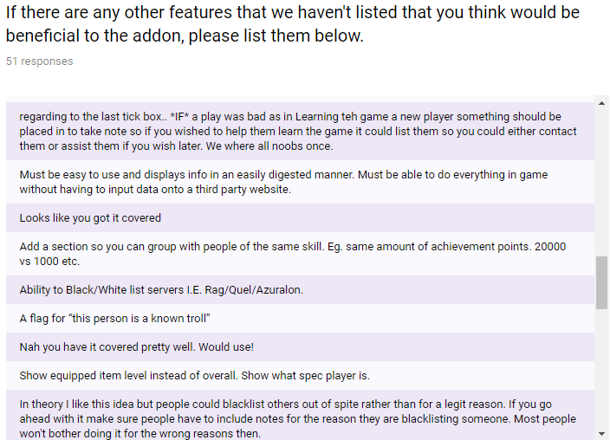

Figure 21: Player Responses Potential Features

After reading through these responses there have been a few that have stood out over the others. Most are small tweaks that we agree would make the addon better and we will do our best to implement their ideas. However, there has been an underlying worry among people that this blacklisting system may have a major flaw. This flaw is that people could blacklist others out of spite, rather than for being toxic, bad or unreliable, also if a player doesn’t like someone and has heaps of friends, they could all blacklist that one person which would be unfair. We are still weighing up whether to affect the ratings that a known toxic player can give out. We are still brainstorming with potential fixes to this problem.

# **Planning and Resources Required**

## **Team Roles Table**

|  |  |
| --- | --- |
| **People** | **Key Responsibilities** |
| Team Leader | In the development for the added functionalities for Wow, also a team leader is responsible for the team knowing and completing tasks on time. The team leader is also responsible for delegating tasks in an equal manner to ensure the success of the project. |
| Group Member | Group members have the responsibility to complete task given to them by the team leader. Group members will do their tasks and assist their team members to ensure the success of the project. |

Table 1: Team Roles Table

## **Project Team Table**

|  |  |  |  |
| --- | --- | --- | --- |
| **Role** | **Name** | **Email** | **Phone** |
| **Team Leader** | Aaaa Griffiths | [kakatroflmao@yahoo.co.nz](mailto:kakatroflmao@yahoo.co.nz) | +0204 158 2831 |
| **Group Member** | Bbbb Isaacs | [isaa99@manukaumail.com](mailto:isaa99@manukaumail.com) | +027 530 7861 |

**Technology Needed**

After looking at the project and seeing the various requirements and involved, the following technology is vital towards not only developing the software but also ensuring that the project becomes an overall success.

### **Google Forms**

The first technology needed for the project is Google Forms. Google Forms is well received user-friendly online survey creation application. Google Forms offers a huge plethora of free tools dedicated to customizing each individual survey to a user’s liking. The survey’s made in Google Forms have the added benefit of seamlessly integrating with other Google applications like “Google Drive”, this feature makes is easily accessible for users to access the survey’s results (Hsu, 2014). Google Forms is great, as it allows users to link their survey to anyone with internet connection and can have virtually unlimited responses. As a bonus creator of surveys can view all results in real time. The last major benefit of using Google Forms over competitors is that it displays response results in automatically generated professional looking graphs, with all results being stored in “Google Spreadsheet”, this saves so much time and effort for users looking to analyse their data and is the ultimate reason why we chose to use it.

### **Logo**



(Ioanna, 2018)

Figure 22: Google Forms Logo

### **Survey Creation**

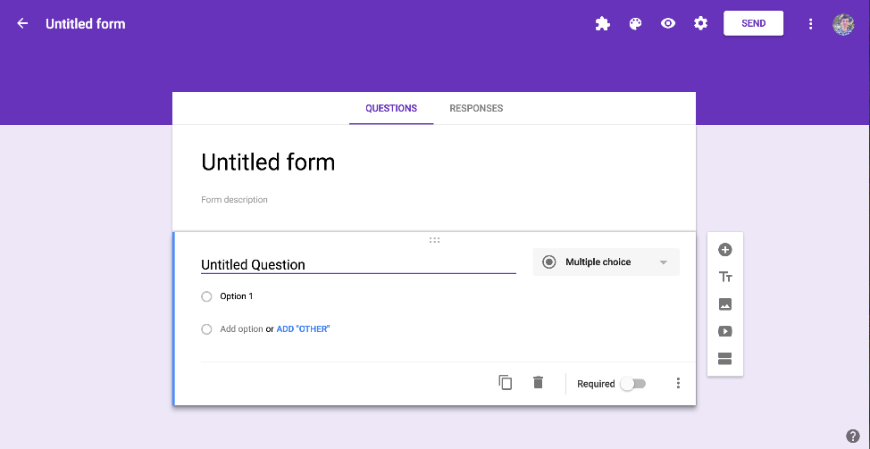

(Guay, n.d.)

Figure 23: Google Forms Survey Creation

### **Responses and Graphs**

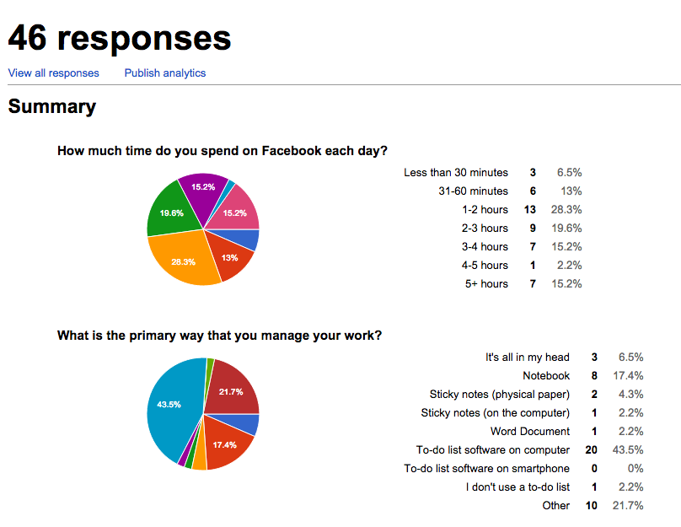

(Magdalena, 2015)

Figure 24: Google Forms Responses and Graphs

### **Notepad++**

The second program we will need to complete our project is Notepad++. Notepad++ is a free software program that will be used to create our add-on’s source code. Notepad++ is essentially a more and powerful extensive text editor that is feature packed with useful tools that can help users, create or edit source code. Notepad++ supports multiple programming languages and users can download different plugins to help better their experience while creating software. The main benefit of using Notepad++ over other text editors is that it allows users to edit code with a feature called tabbed editing, this feature allows users to work with multiple open files in a single window. But the main reason we choose Notepad ++ over other text editors is because it supports syntax highlighting. Syntax highlighting is very useful for developers to create source code as it adds structure to the text file.

### **Logo**



(HTML & CSS Editor: NotePad++, 2018)

Figure 25: Notepad++ Logo

### **Coding in Notepad++**

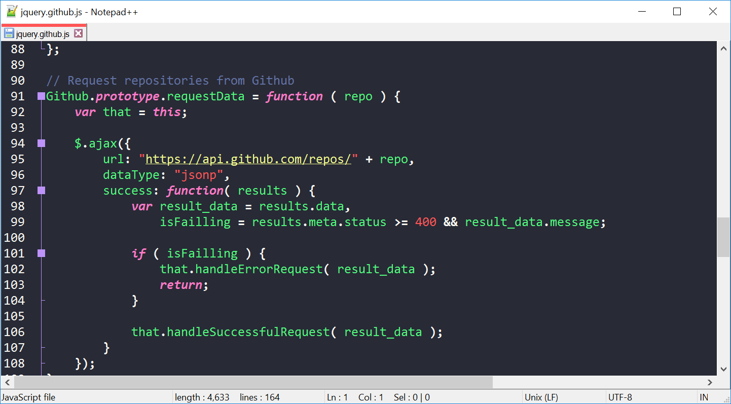

(Rocha, n.d.)

Figure 26: Coding in Notepad++

### **Coding with tabs**

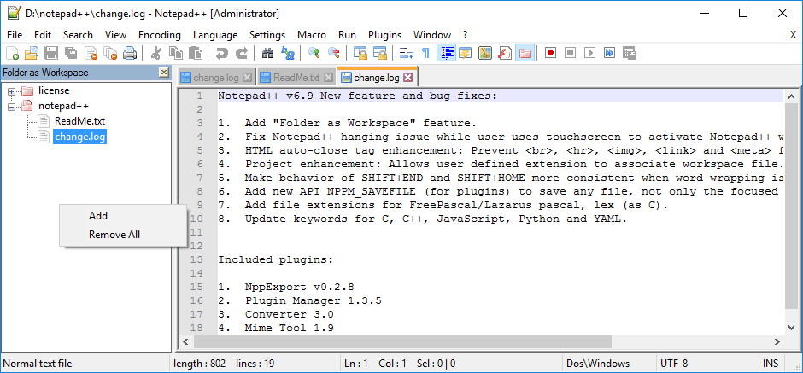

(Venkat, 2017)

Figure 27: Coding with Tabs in Notepad++

Project Phases

### **Forming and Planning Phase**

This phase is the starting point for the entire project. In this this phase the tasks are mostly centred around the formation our group. This phase is also where we need to select a topic for our project.

### **Research Topic Phase**

In this phase our group should have a clear understanding of what our topic for the project is going to be. We will need to meet with our lecturer to explain to him our topic and clarify how we envision the end goal for project. We will also need to do some initial research so that we can answer the following questions:

* What is our Project Scope?
* Our project is possible to do?
* What technologies are required to complete this project?
* Who are the main stakeholders and how will this affect them if the project is a success?
* What is the overall MOV and its impact for this project?
* How do add-ons function in WoW?

### **Data Collection Phase**

After we’ve gained a better understanding on our project through doing the research phase, we can begin the next phase of our project which is the data collection phase. In this phase our group will create a survey that will be set up to ask community members of WoW, if this add-on is needed and what functionalities would they add to gain a better experience while playing the game. The survey will be created on Google Forms as this will make it easier for our group to set up the survey and share it online. Google Forms will also display the data in an attractive manner. This is important, and it should make it easy for us to discuss our survey results with our lecturer as the data is being displayed through visual pleasing graphs.

### **Writing Proposal Phase**

Once our group have analysed the survey’s results, we can proceed to the next phase of project which is writing the proposal report. The proposal report is essentially an in-depth explanation highlighting the purpose of the project which includes the aims and objectives of the project. This phase needs to be done on time before starting the next as it is basically the plan for the project. Our proposal report will be comprised of an:

* Introduction
* Literature review
* Research Approach
* Development Methodology
* Project Resources
* Projects overall plan
* Conclusion

### **Proposal Presentation Phase**

When the proposal document has been completed the next phase of the plan can commence. In this phase we are going create a short presentation that explains our project our topic, proposal plan and some of our research. We will need to do some practice during this phase as the presentation will only be about ten minutes which means we should practice making sure that we get all our points across to the audience.

### **Design Phase**

Now we arrive at the most interesting part of the entire project the design phase. This phase will essentially be the phase in which we design the add-on and its functionalities. With this said before we start we will need to do extensive research on databases, algorithms, software design and user graphical user interfaces (GUI) to start designing the add-on and its functionalities. This phase will probably be the hardest to complete be also the most enjoyable.

### **Development Phase**

The next stage in our project is the development phase. In this phase we will develop and test the add-on as well as integrate it onto the latest version of WoW. This phase will primarily be broken up into three key stages which include:

* Develop System Modules
* Integrate System Modules
* Perform Tests

### **Documentation Phase**

The last phase of project is to write the software documentation. This is an important phase as it will serve as way for our group to record all the aspects of our add-on and if done correctly it should be able to improve the quality of our add-on by recording and documenting the functionalities development, maintenance and additional knowledge to other developers. This is a crucial phase in our project and need to be done properly, so accuracy is key.

### **4.5 Project Work Structure**

4.5.1

**Forming and Planning Phase Table**

|  |  |  |  |  |  |
| --- | --- | --- | --- | --- | --- |
| **Appendix** | **Task Name** | **Start** | **Finish** | **Task Breakdown** | **Resource Names** |
| **1** | **Forming and Planning Phase** | **Tue 20/02/18** | **Tue 20/02/18** |  |  |
| **1** | Form Group | Tue 20/02/18 | Tue 20/02/18 | Aaaa and Bbbb came together and decided to be partners for hot topic. | Aaaa, Bbbb, |
| **1** | Brainstorm Topic Ideas | Tue 20/02/18 | Tue 20/02/18 | Three potential topic ideas were talked about. Johns multiplayer networking project, a simple progression game on android phone and lastly a WoW addon used as a method of displaying more information on a player via a home-made reputation system. | Aaaa, Bbbb |
| **1** | Select Topic | Tue 20/02/18 | Tue 20/02/18 | We quickly decided on the WoW addon as it would be more beneficial to a wider variety of people than the other ideas and also interested us the most which we believe is important. | Aaaa, Bbbb, |

Table 3:Forming and Planning Phase Table

4.5.2

**Research Topic Phase Table**

|  |  |  |  |  |  |  |  |
| --- | --- | --- | --- | --- | --- | --- | --- |
| **Appendix** | **Task Name** | | **Start** | **Finish** | **Task Breakdown** | | **Resource Names** |
| **1** | **Research Topic Phase** | **Tue 20/02/18** | | **Wed 21/02/18** | |  |  |
| **1** | Research World Warcraft Add-ons | Tue 20/02/18 | | Wed 21/02/18 | | We were looking into WoW addons in general and specific addons that did a similar thing to us and found only one other called BadApples. We tried this out, but it was only a very small version of what we were doing and was poorly done. | Aaaa, Bbbb |
| **1** | Group Meeting Discuss Research Findings | Wed 21/02/18 | | Wed 21/02/18 | | Aaaa and Bbbb had a meeting to discuss and exchange their findings during the previous phase. | Bbbb, Aaaa |
| **1** | Group Meeting with Lecturer | Wed 21/02/18 | | Wed 21/02/18 | | We had a meeting with Fadi about our idea and discussed our scope with him and it was approved. Fadi encouraged the creation of an online survey to research further into the idea that this would be beneficial to the WoW community from the perspective of the community itself. | Aaaa, Bbbb |

Table 4: Research Topic Phase Table

4.5.3

**Data Collection Phase Table**

|  |  |  |  |  |  |  |  |  |
| --- | --- | --- | --- | --- | --- | --- | --- | --- |
| **Appendix** | **Task Name** | **Start** | | **Finish** | | **Task Breakdown** | | **Resource Names** |
| 1 | **Data Collection Phase** | | **Wed 21/02/18** | | **Sat 24/02/18** | |  |  |
| 1 | Create Survey | | Wed 21/02/18 | | Wed 21/02/18 | | Create an online survey via Google Forms with questions based on our research findings to learn about the desired functionalities of the addon and give us an idea of the general qualities of the community. | Aaaa, Bbbb |
| 1 | Handout Survey to community members | | Thu 22/02/18 | | Fri 23/02/18 | | The first day after 6 hours of searching Aaaa found 30 people to complete the survey. He then searched for an admin for a popular WoW Facebook page (as you aren’t allowed to post surveys on pages without permission) which netted us 208 total responses after 4 days. | Aaaa |
| 1 | Group Meeting with Lecturer - Review Survey Results | | Fri 23/02/18 | | Sat 24/02/18 | | This meeting was to show Fadi our results of the survey and got confirmation to start the proposal | Aaaa, Bbbb |

Table 5: Data Collection Phase Table

4.5.4

**Writing Proposal Phase Table**

|  |  |  |  |  |  |
| --- | --- | --- | --- | --- | --- |
| **Appendix** | **Task Name** | **Start** | **Finish** | **Task Breakdown** | **Resource Names** |
| **2** | **Writing Proposal Phase** | **Tue 27/02/18** | **Fri 2/03/18** |  |  |
| **2** | Group Meeting - Discussing Project Proposal | Tue 27/02/18 | Tue 27/02/18 | This meeting was essentially to discuss the following steps in this block of the Gantt chart, so we could follow a guideline to finish the proposal. | Aaaa, Bbbb |
| **2** | Write Introduction | Tue 27/02/18 | Tue 27/02/18 | The introduction to the proposal was written on this day | Aaaa |
| **2** | Write Literature review | Wed 28/02/18 | Wed 28/02/18 | The literature review was written on this day | Aaaa, |
| **2** | Write Research Approach | Wed 28/02/18 | Thu 1/03/18 | The Research approach section of the proposal was written on this day | Aaaa, Bbbb |
| **2** | Write about Methodology | Thu 1/03/18 | Thu 1/03/18 | The methodology section of the proposal was written on this day | Aaaa, Bbbb |
| **2** | Write About Project Resources | Fri 2/03/18 | Fri 2/03/18 | The project resources section was written on this day | Bbbb |
| **2** | Write on the projects overall plan | Fri 2/03/18 | Fri 2/03/18 | The projects overall plan was written on this day | Bbbb |
| **2** | Write Conclusion | Fri 2/03/18 | Fri 2/03/18 | The conclusion was written on this day | Aaaa, Bbbb |

Table 6:Writing Proposal Phase Table

4.5.5

**Proposal Presentation Phase Table**

|  |  |  |  |  |  |
| --- | --- | --- | --- | --- | --- |
| **Appendix** | **Task Name** | **Start** | **Finish** | **Task Breakdown** | **Resource Names** |
| **2** | **Proposal Presentation Phase** | **Sat 3/03/18** | **Wed 7/03/18** |  |  |
| **2** | Create PowerPoint | Sat 3/03/18 | Sat 3/03/18 | Create a PowerPoint to use as a resource to display information during the presentation | Bbbb |
| **2** | Presentation Preparation | Sun 4/03/18 | Sun 4/03/18 | Write cue cards for the presentation and print them out so we have more of a reference than just the PowerPoint | Aaaa, Bbbb |
| **2** | Practice Presentation | Tue 6/03/18 | Tue 6/03/18 | Go through the cue cards together so we can get a flow of what we are going to say and when and memorise it so that we can look around the class and be engaging during presentation | Aaaa, Bbbb |
| **2** | Present Presentation | Tue 6/03/18 | Wed 7/03/18 | Present first out of all the groups following the practice as closely as possible | Bbbb, Aaaa |

Table 7: Proposal Presentation Phase Table

4.5.6 **Proposal Presentation Phase Table**

|  |  |  |  |  |  |
| --- | --- | --- | --- | --- | --- |
| **Appendix** | **Task Name** | **Start** | **Finish** | **Task Breakdown** | **Resource Names** |
| **3** | **Design Phase** | **Wed 7/03/18** | **Wed 21/03/18** |  |  |
| **3** | Research Databases | Wed 7/03/18 | Fri 9/03/18 | Research cloud databases that we can connect to the back end of our addon to store values that make up the blacklisting statistics for each player | Aaaa, Bbbb |
| **3** | Design Database | Fri 9/03/18 | Mon 12/03/18 | Build the database so we have a place to store the entries once the addon is up and running | Aaaa, Bbbb |
| **3** | Software Design | Thu 15/03/18 | Mon 19/03/18 | This is where we use API’s within WoW’s programming in Lua to create the backend code for the addon | Aaaa |
| **3** | Interface Design | Tue 20/03/18 | Tue 20/03/18 | This is where we will create the GUI which is what the player uses in game | Bbbb |
| **3** | Create Design Specification | Wed 21/03/18 | Wed 21/03/18 | We will create tweaks here to make the addon better by fine tuning aspects that we and community feedback think would make the addon run more smoothly and have more intuitive functionalities | Aaaa, Bbbb |

Table 8:Proposal Presentation Phase Table

4.5.7 **Development Phase Table**

|  |  |  |  |  |  |  |
| --- | --- | --- | --- | --- | --- | --- |
| **Appendix** | **Task Name** | **Start** | **Finish** | | **Task Breakdown** | **Resource Names** |
| **3** | **Development Phase** | **Thu 22/03/18** | | **Tue 27/03/18** |  |  |
| **3** | Develop System Modules | Thu 22/03/18 | | Fri 23/03/18 | Develop the methods used within the database | Aaaa, Bbbb |
| **3** | Integrate System Modules | Mon 26/03/18 | | Mon 26/03/18 | Create these methods in the database | Aaaa, Bbbb |
| **3** | Perform Tests | Tue 27/03/18 | | Tue 27/03/18 | This is the testing phase to ensure that the addon is fully functional | Aaaa, Bbbb |

Table 9:Development Phase Table

4.5.8

**Documentation Phase Table**

|  |  |  |  |  |  |
| --- | --- | --- | --- | --- | --- |
| **Appendix** | **Task Name** | **Start** | **Finish** | **Task Breakdown** | **Resource Names** |
| **3** | **Documentation Phase** | **Wed 28/03/18** | **Fri 30/03/18** |  |  |
| **3** | Document Entire Project | Wed 28/03/18 | Thu 29/03/18 | We will document all our findings and learnings throughout this entire project | Aaaa, Bbbb |
| **3** | **End** | Fri 30/03/18 | Fri 30/03/18 | Project completion |  |

Table 10:Documentation Phase Table

## **4.6 Key risks and impact**

During the completion of this project its enviable that certain issues will occur that will stunt the project overall production. These areas must be identified and avoided for the project’s success.

### **4.6.1. Risks associated with project**

**Lack of add-on development expertise risk -** Creating new software can be a challenging process and it is not easy. This is true even for the most experienced developers, and in our case, this is especially true due to us being unexperienced developers. As unexperienced developers our group naturally have a plethora of challenges and problems when developing the add-on for WoW as we simply lack the expertise to produce our goal.

**Time management and scheduling risk** **-** Due to our group’s inexperience developing software we might fall behind the projects time deadlines. This is due to our group having never done anything on this project scale. We might not have enough time to complete the project to our liking, and this can be due to a multitude of factors like errors with initial phase estimations, failure to reach set project milestones or even natural factors can sometimes come into play. These factors can cause failure with the project.

**Scope risk -** It is important for our project that we understand the project scope. Many projects have failed due a to teams having misunderstandings on what their project’s overall scope is. If a project does not have a proper scope management plan most times it can result in:

* Scope creep –Where the project keeps growing in complexity as more adding more functionalities outside of the scope are added.
* Integration issues - due to changes with the project requirements
* Hardware & Software faults
* Change in needs

**Technology Risk -** Failure with technology can have a huge impact on project’s success rate, as many issues with technology can arise over a project timespan. At any time, an issue with our devices can cause devastating loss to our group’s progression as all our work will be done on our computers. So, in any case if there is ever a failure with our devices, it could result in with us losing all our work.

**Communication Risk -** lack of communication between group members is probably the biggest risk our group faces during the project’s life cycle. Improper communication could cause unnecessary problems and setbacks due to confusion and miscommunication which sometimes arise between group members. This could ultimately cause a group to lose sight of the common goals set out in the beginning of the project and can cause group member conflicts.

### **4.6.2 Resolution of Risks Table**

|  |  |
| --- | --- |
| **Risks:** | **Resolution**: |
| **Lack of add-on development expertise Risk** | If there is a lack of understanding on how to do something regarding coding, ask for help from senior developers and do extensive research on problems found in the coding phase. |
| **Time management and scheduling Risk** | Create a Gantt chart that clearly explains phases and tasks project deadlines. |
| **Scope Risk** | Create a scope management plan that clearly explains the processes required to do complete the project. |
| **Technology Risk** | Save all project work on a regular basis on a portable hard drive or USB. |
| **Communication Risk** | Have frequent group meetings so each team member can voice their own individual opinion regarding how the feel about how project is going. |

Table 11: Resolution of Risks Table

# **Conclusion**

In conclusion we are optimistic of the project though we lack the knowledge on addon development, we still believe that the project has potential to be an amazing success. As young developers, we need to challenge ourselves in order to succeed in this industry and it is also our responsibility as future developers to better other people’s lives. We will look to do this by taking feedback from relevant communities and looking at user requirements to create user-friendly useful software.

# **References**

Blizzard. (2018). Retrieved from Blizzard Entertainment: https://www.blizzard.com/en-us/

Brinks, M. (n.d.). *12 Games That Can't Escape Their Own Aggressively Toxic Communities*. Retrieved from Ranker: https://www.ranker.com/list/video-games-with-toxic-communities/melissa-brinks

Guay, M. (n.d.). *Google Forms Guide: Everything You Need to Make Great Forms for Free*. Retrieved from Zapier: https://zapier.com/learn/google-sheets/how-to-use-google-forms/

Hsu, J. (2014, May 20). *TechSoup Battles: Joyce Reviews Google Forms*. Retrieved from techsoup.

*HTML & CSS Editor: NotePad++*. (2018). Retrieved from 101computing: http://www.101computing.net/html-editor/

Ioanna, D. (2018). *What is G Suite?* Retrieved from datacable: http://www.datacable.co.uk/website/services/g-suite-for-education/

Magdalena. (2015, November 7). *THE QUICKEST WAY TO ANALYZE RESULTS WITH GOOGLE FORMS*. Retrieved from SoupofMedia: http://www.soupofmedia.com/the-quickest-way-to-analyze-results-with-google-forms/

McKee, S. (2013, October 22). *New Quantitative Research Questions in Online Surveys*. Retrieved from SurveyGizmo: https://www.surveygizmo.com/resources/blog/new-ways-to-ask-quantitative-research-questions-in-online-surveys/

Millikin, L. (2016, 14 July). *Quantitative Questions Versus Qualitative Questions in Surveys*. Retrieved from SurveyGizmo: https://www.surveygizmo.com/resources/blog/quantitative-qualitative-questions/

MMOByte. (2017, 12 14). *Top 10 Most Played MMORPGs in 2018 - What MMOs You SHOULD Be Playing!?!* Retrieved from Youtube: https://www.youtube.com/watch?v=KagH6GAxXNI

Raizing. (2017, 6 15). *Regarding active subs*. Retrieved from Battle.net: https://us.battle.net/forums/en/wow/topic/20755767500

Rocha, Z. (n.d.). *A dark theme for Notepad++ and 40+ apps*. Retrieved from Dracula: https://draculatheme.com/notepad-plus-plus/

Stachowiak, S. (2017, September 20). *The Best Guide to Google Forms You’ll Ever Find*. Retrieved from MakeUseOf: https://www.makeuseof.com/tag/best-guide-google-forms/

Venkat. (2017, January 30). *Notepad++ 6.9 adds most wanted ‘Folder as Workspace’ Feature*. Retrieved from Techdows: http://techdows.com/2016/02/notepad-6-9-adds-folder-as-workspace.html

*World Of Warcraft Reddit*. (2018). Retrieved from Reddit: https://www.reddit.com/r/wow/comments/7axc30/battle_for_azeroth_box_cover_mock_up_based_on/

# 

# **APPENDIX 1**

**The Image below will display the following phases, and their task structure:**

* **Forming and Planning Phase**
* **Research Topic Phase**
* **Data Collection Phase**

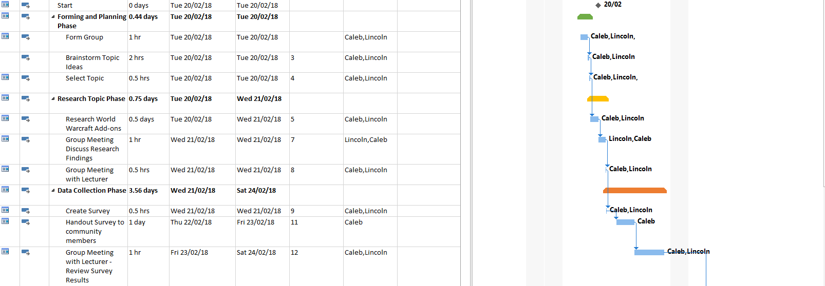

Figure 28: APPENDIX 1

# **APPENDIX 2**

**The Image below will display the following phases, and their task structure:**

* **Writing Proposal Phase**
* **Proposal Presentation Phase**

Figure 29: APPENDIX 2

# **APPENDIX 3**

**The Image below will display the following phases, and their task structure:**

* **Design Phase**
* **Development Phase**
* **Documentation Phase**

Figure 30:APPENDIX 3

|  |  |
| --- | --- |
|  | **Faculty of Business and Information Technology****502.714 – Hot Topic in Software**  Proposal Cover Sheet |
| Assessment | Project Proposal |
| Student IDs: |  |
| Student Name(s): |  |
| Student MIT email: |  |
| Submitted to Canvas: | Date: |
| **Declaration of Original Authorship**  1. This assignment is my own original work. 2. I have not copied either partially or in full any work from any other student or former student at Manukau Institute of Technology or any other tertiary institution. 3. This assignment has not previously been submitted for assessment, either in whole or in part, for any other course at Manukau Institute of Technology or any other tertiary institution. 4. I have acknowledged all sources of information used in the writing of this assignment by using the recognised in-text APA referencing standard. All unpublished sources of information have been acknowledged. 5. I understand that MIT may make use of systems such as Turnitin.com to verify the originality of my work.   I make this declaration in full knowledge and understanding that, should it be found false, Manukau Institute of Technology may take action according to MIT Policy AM6 Misconduct in Assessment.  Signed by Student(s):  Date: 14/03/2018 | |